DevOps Application Deployment Capstone
GITHUB URL: https://github.com/psakthiece/Devops-build-Project.git
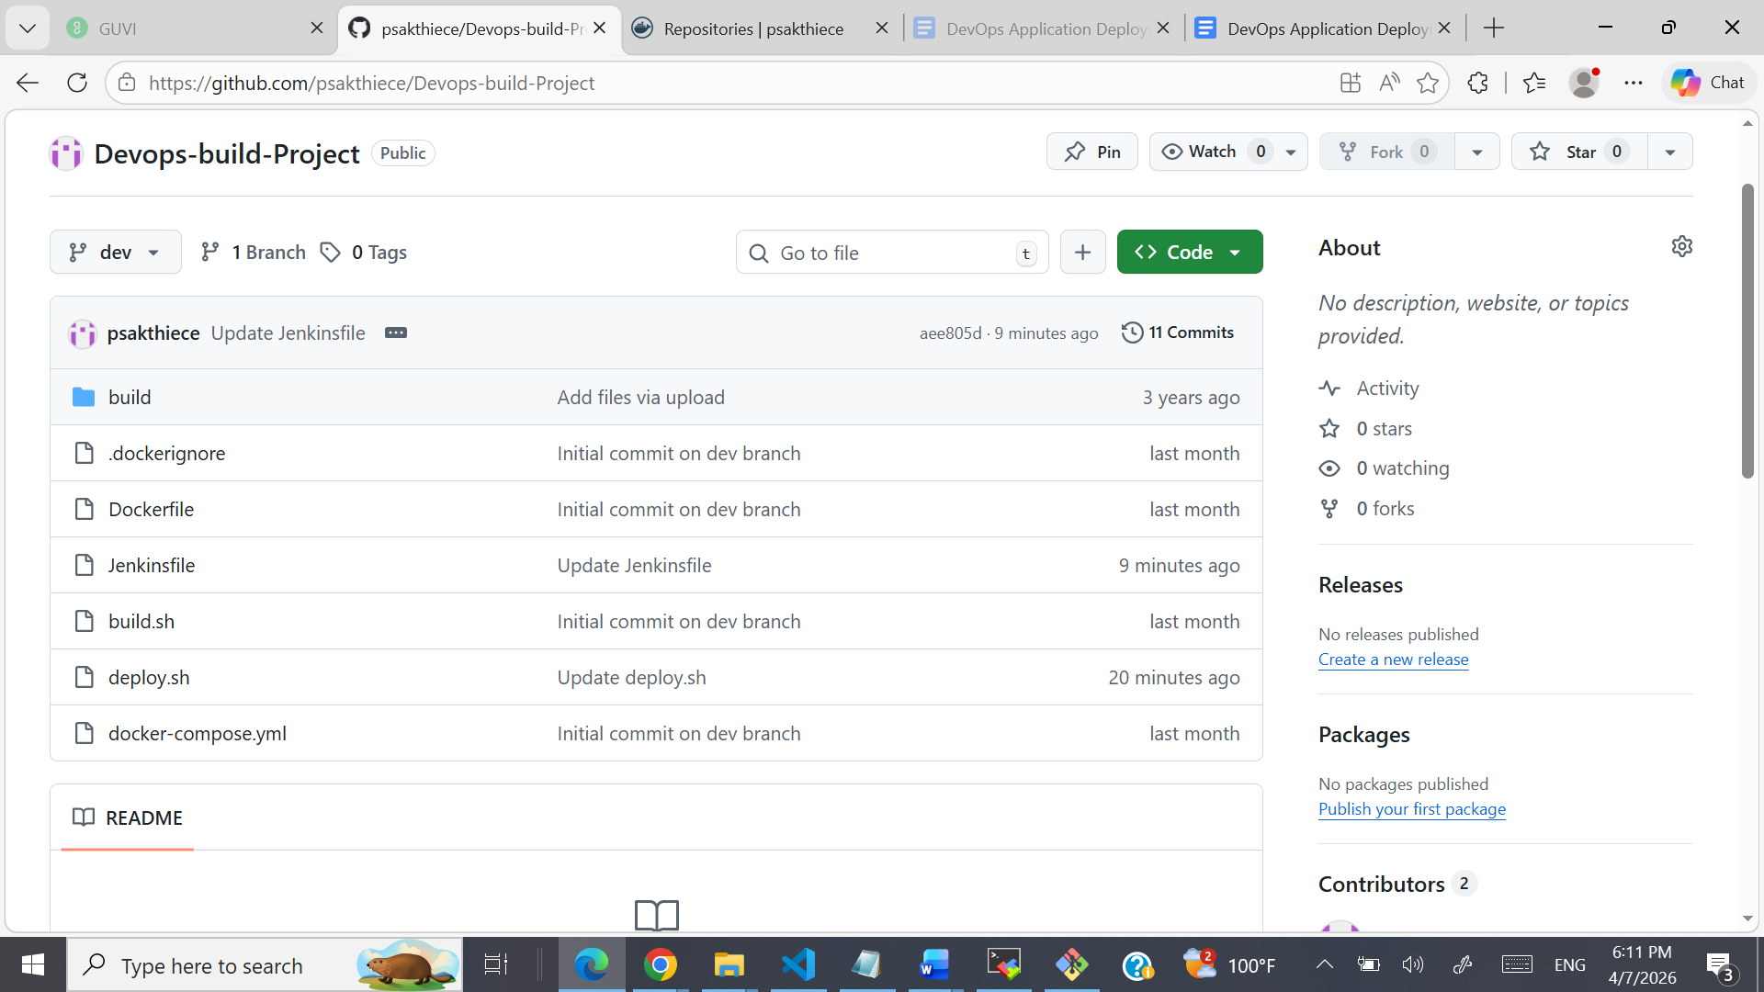
Deployed SITE URL: http://18.207.130.95/



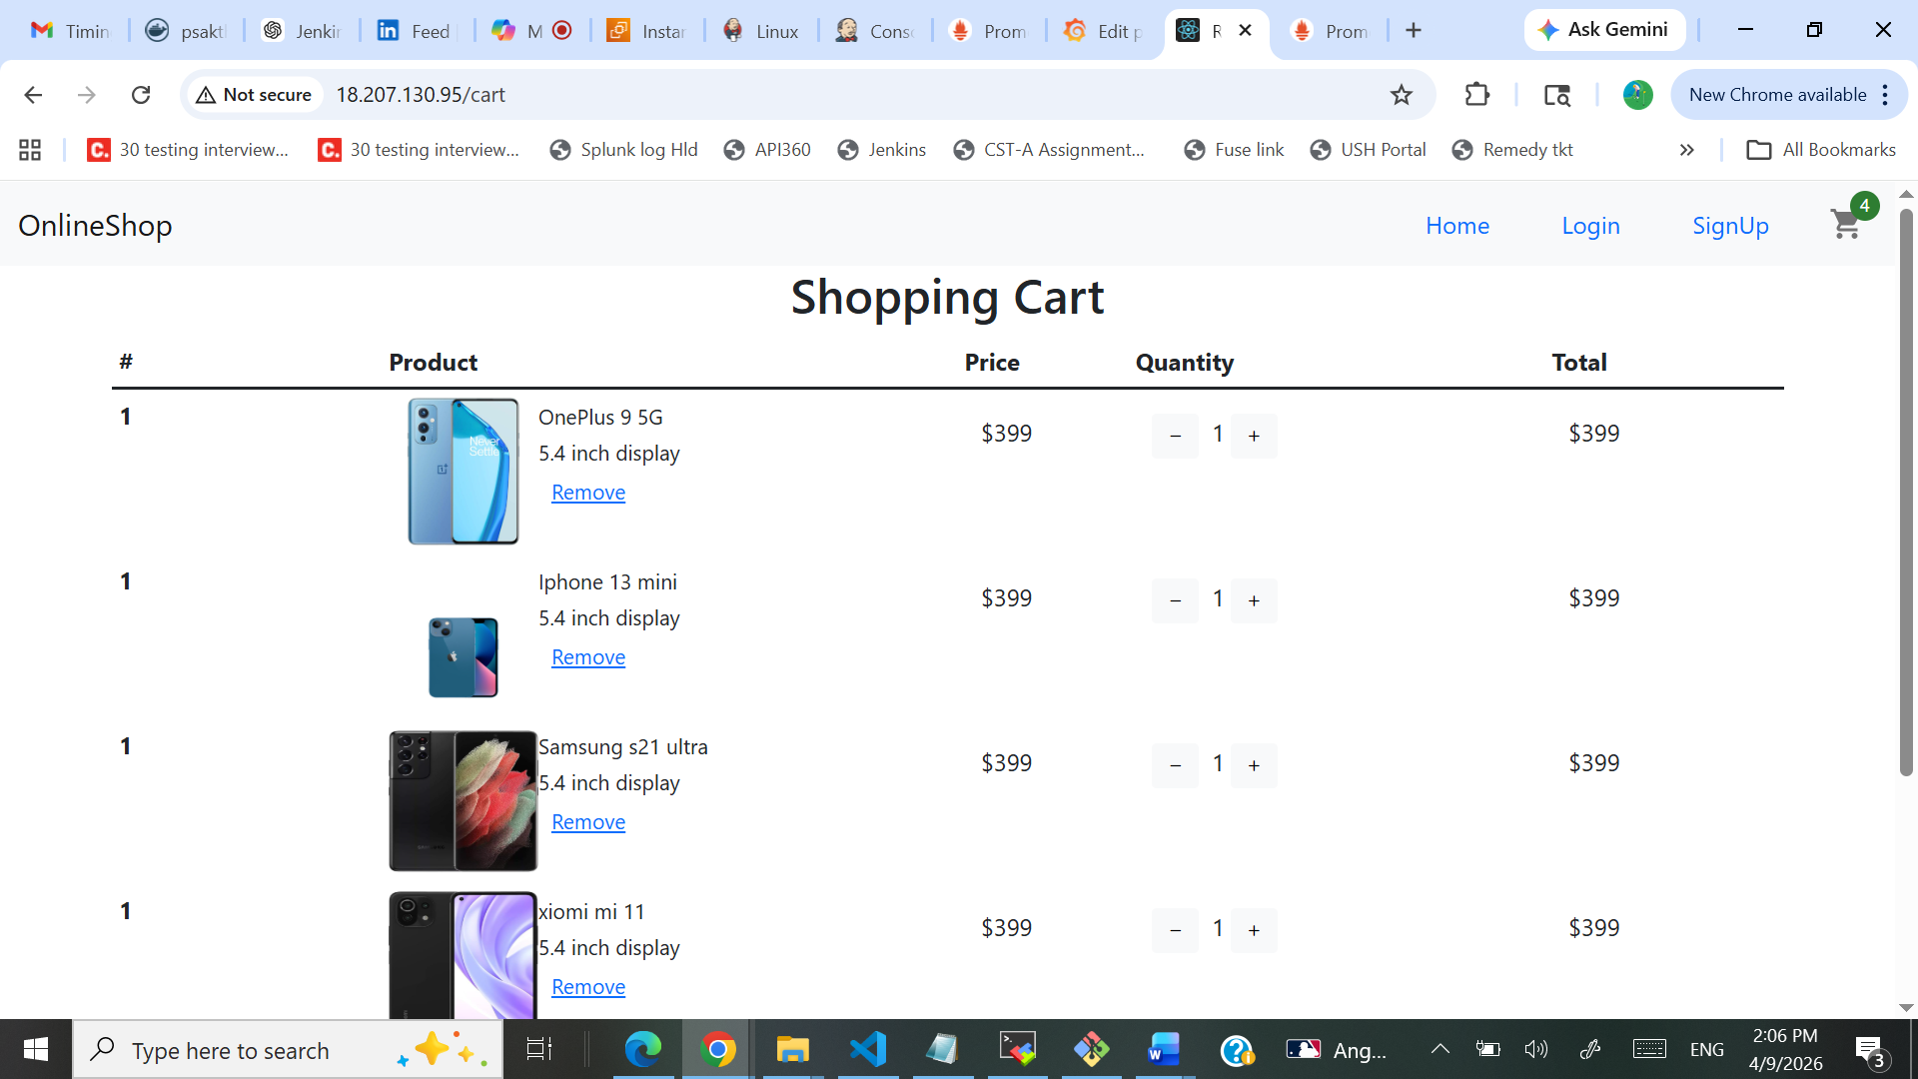
Docker Images uploaded in Docker hub:
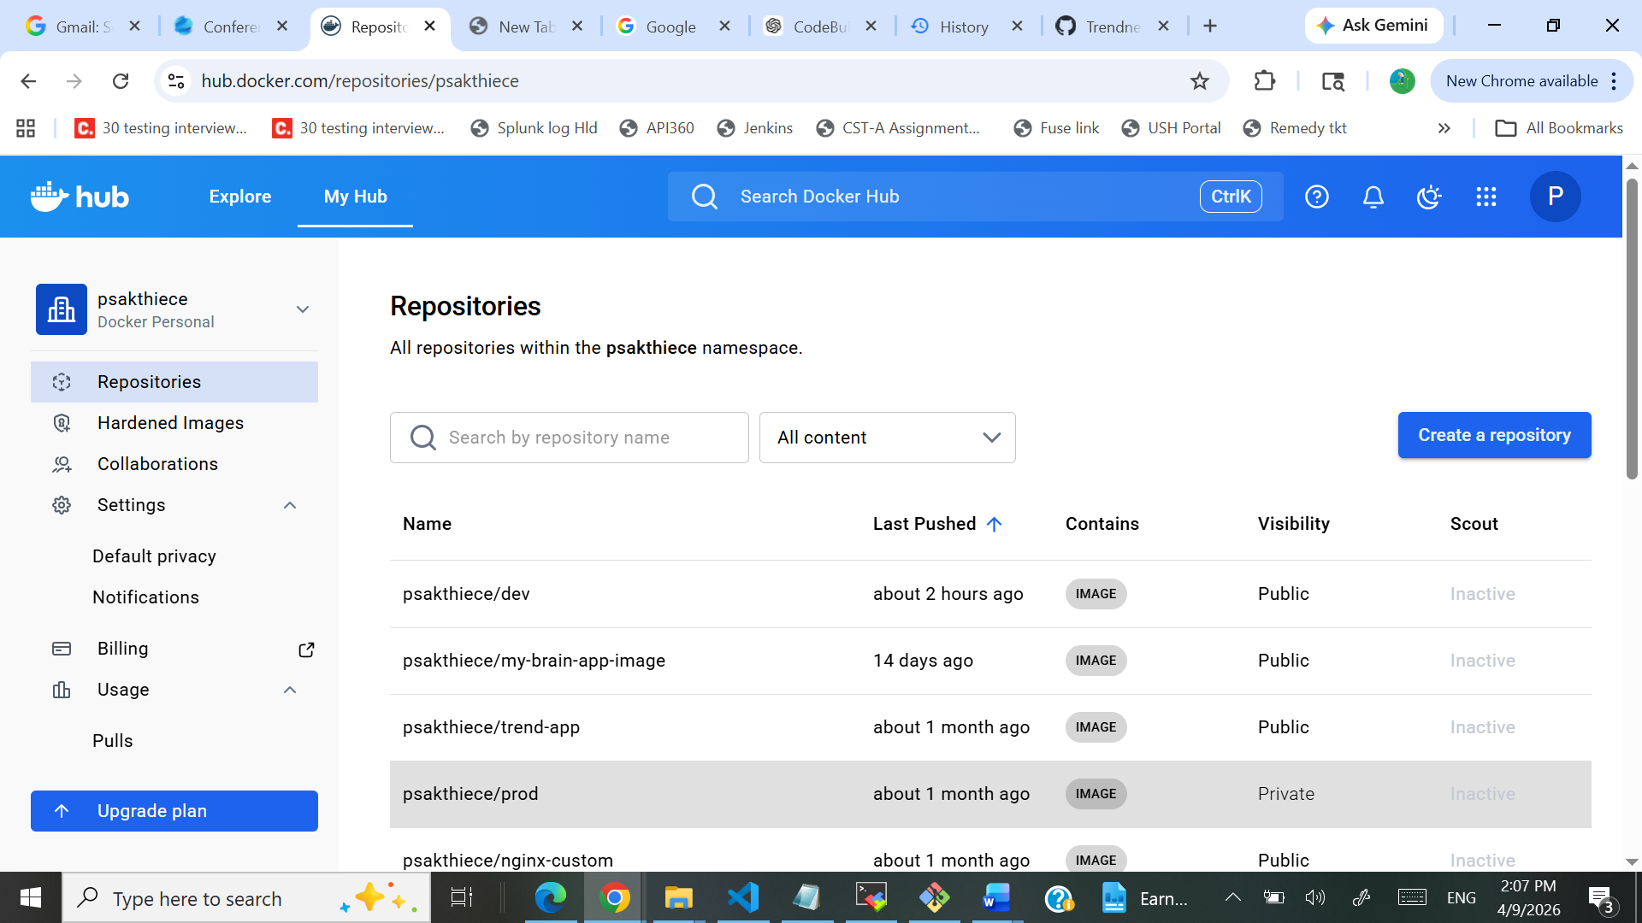
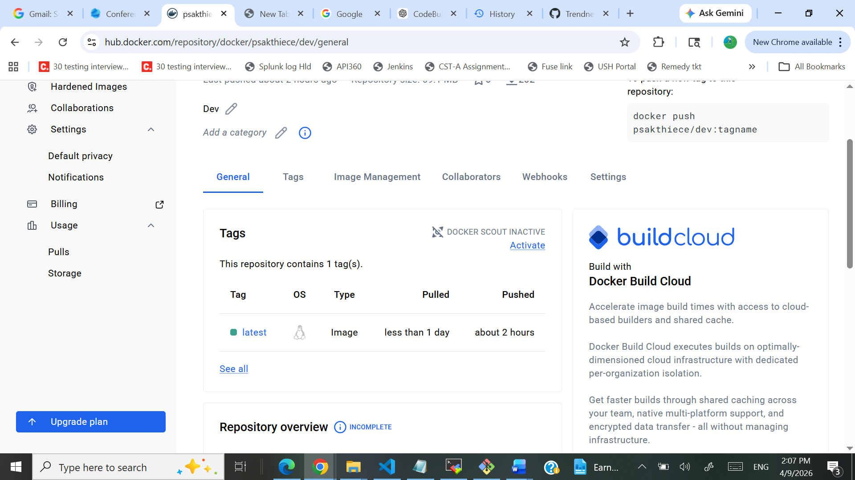

EC2 Instance: Public IP: 18.207.130.95
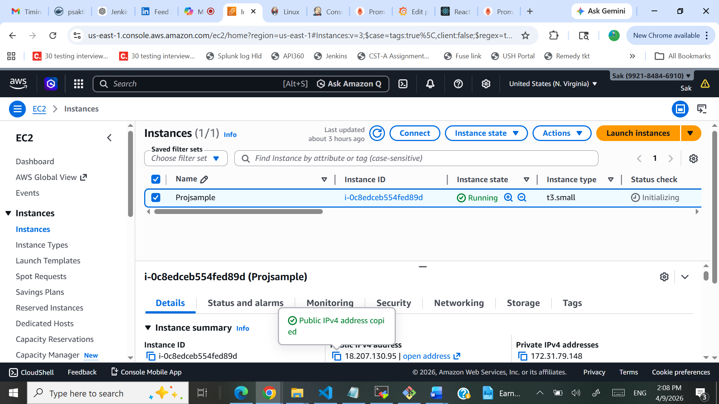
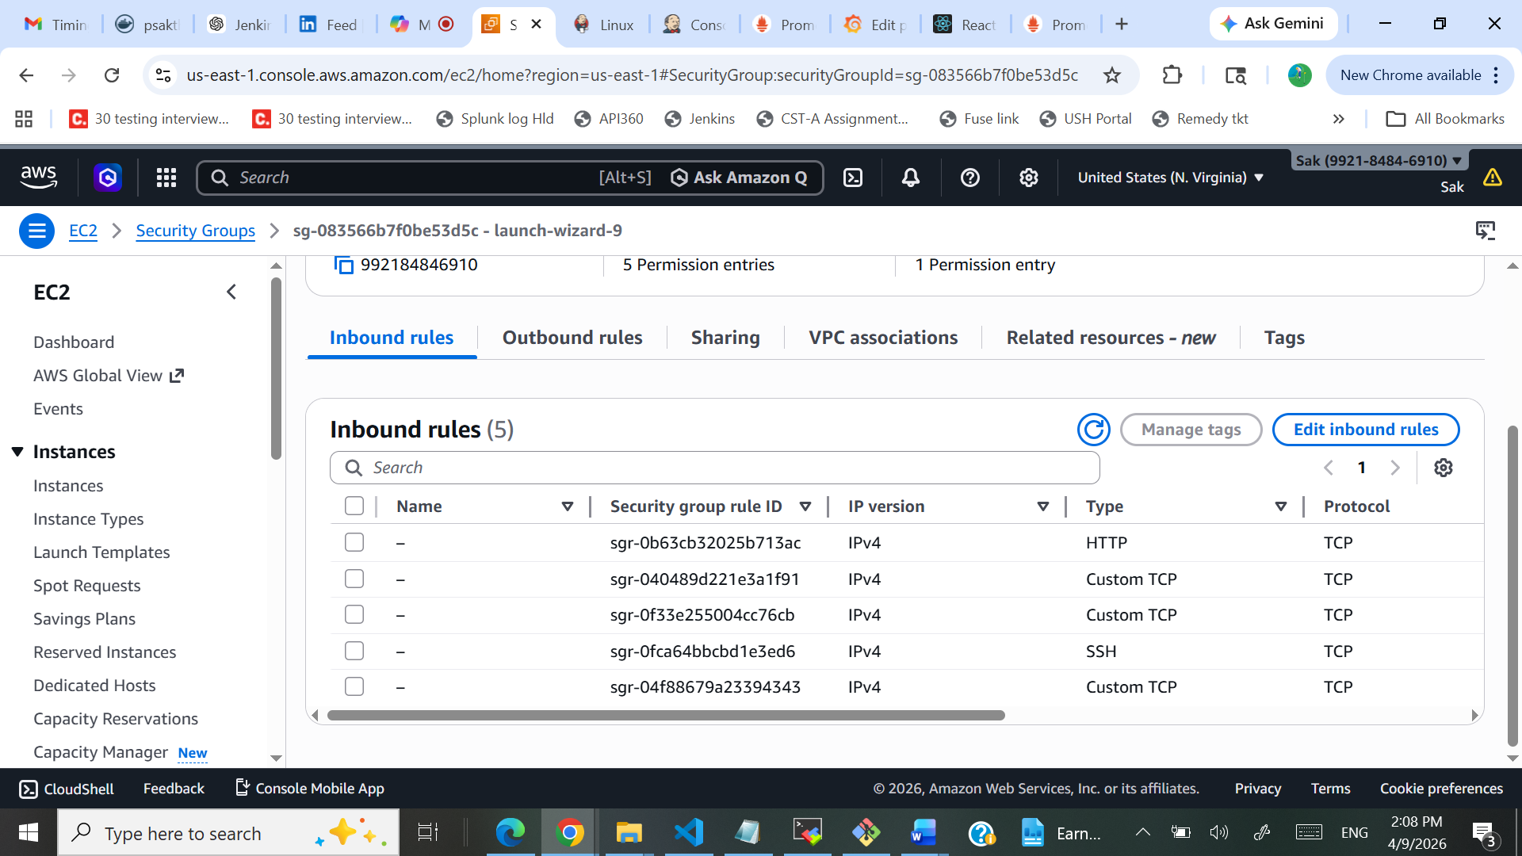

Jenkins installed in EC2 : http://18.207.130.95:8080/
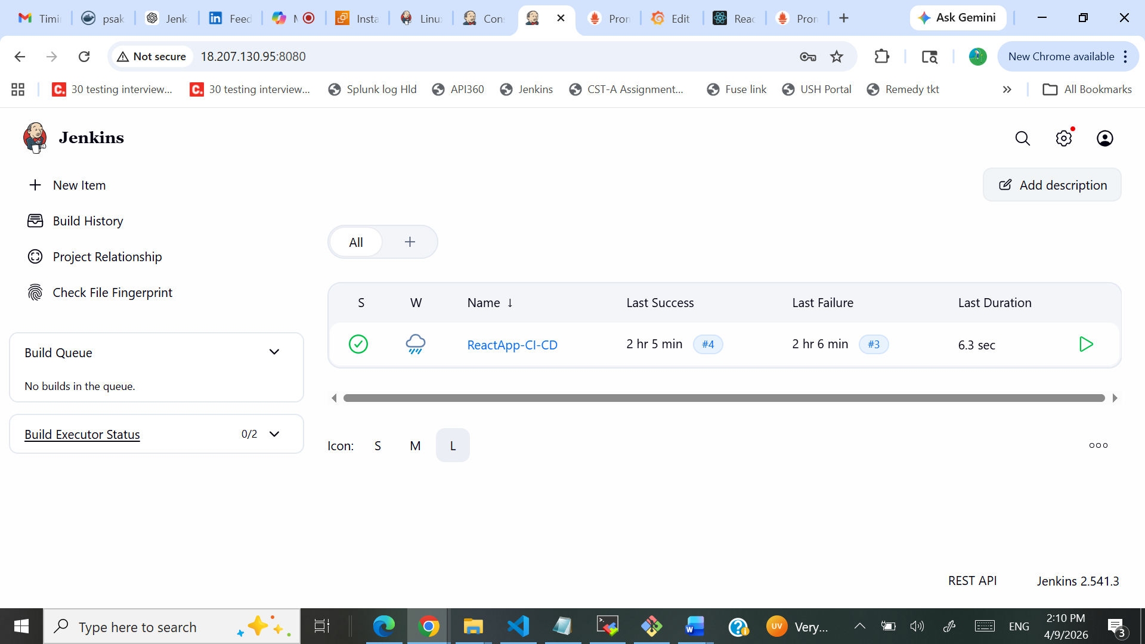
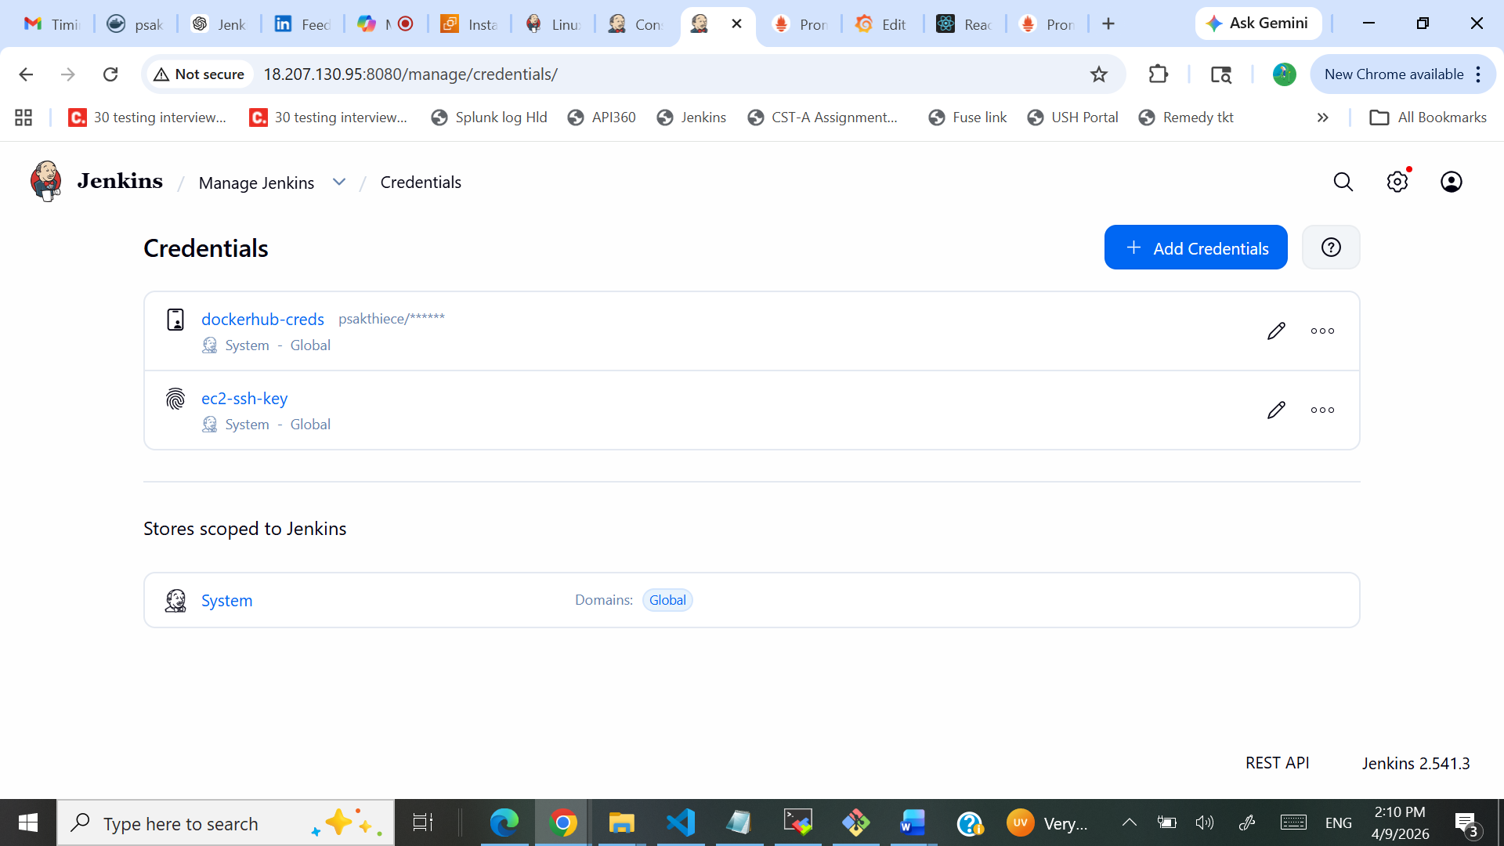
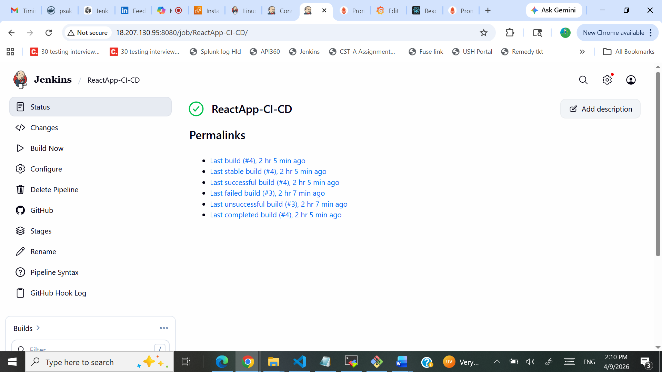
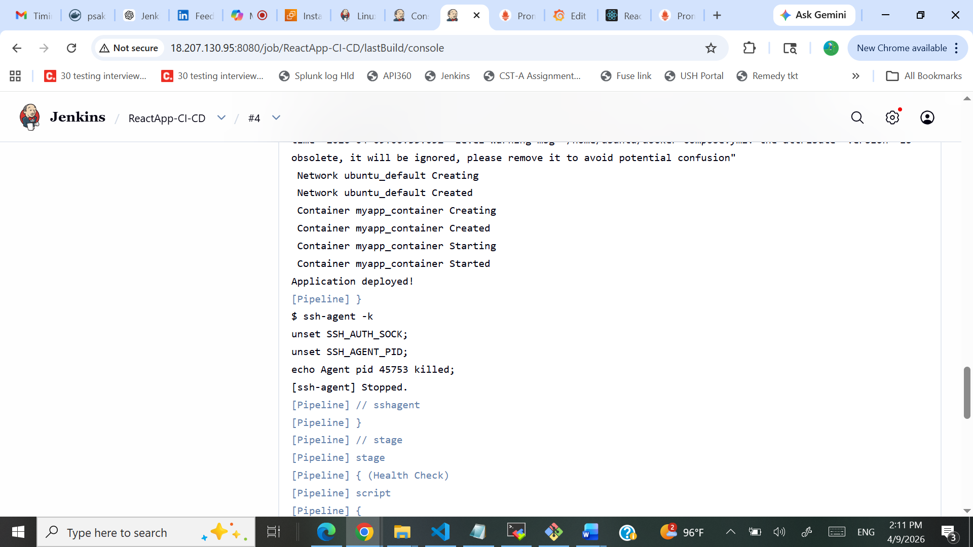
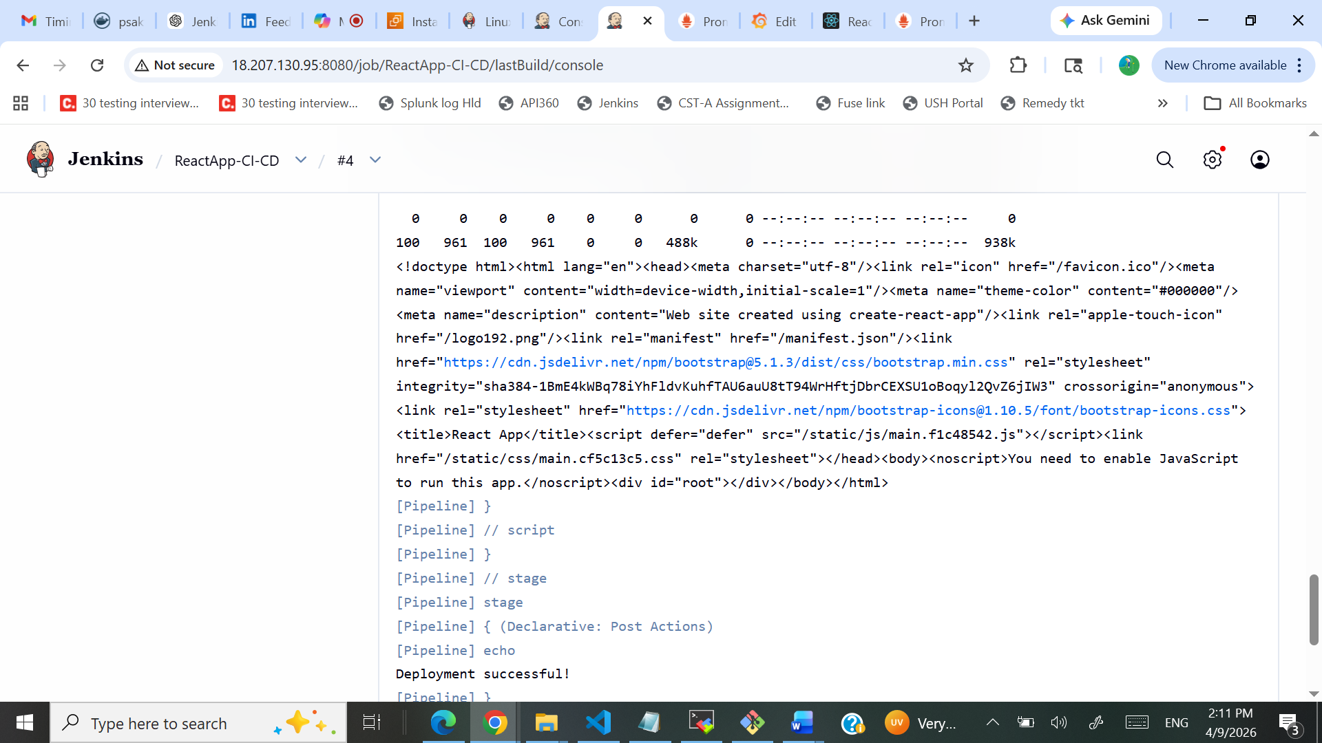
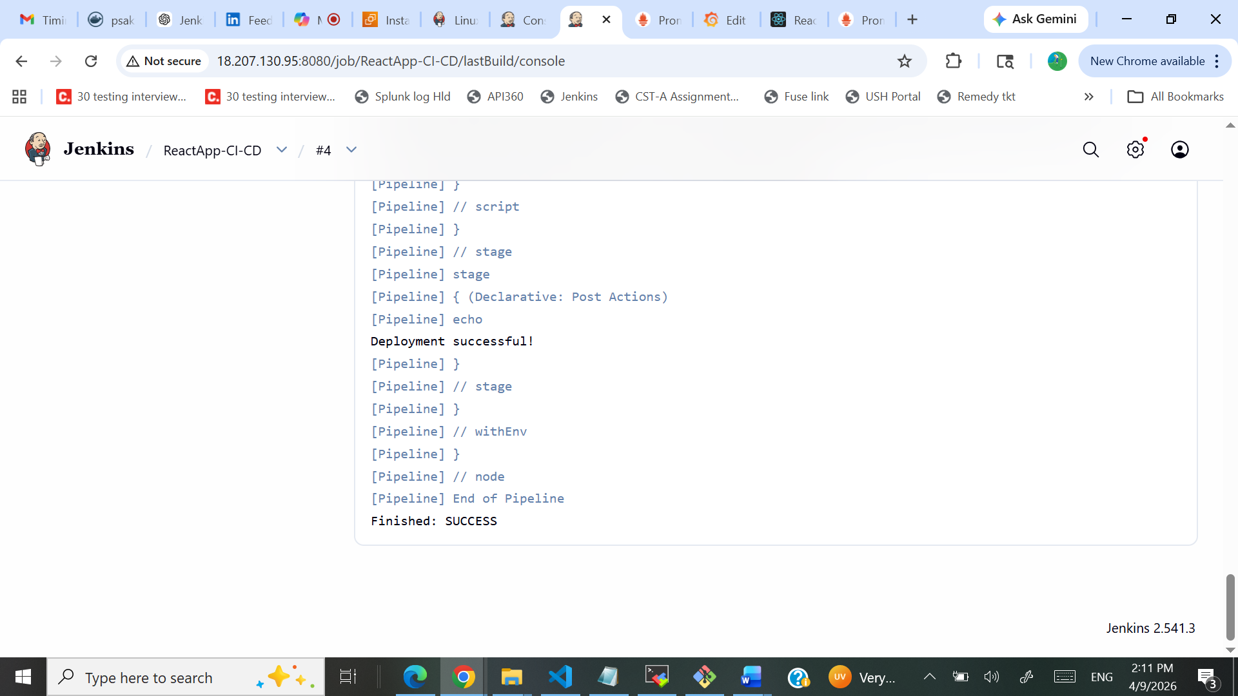

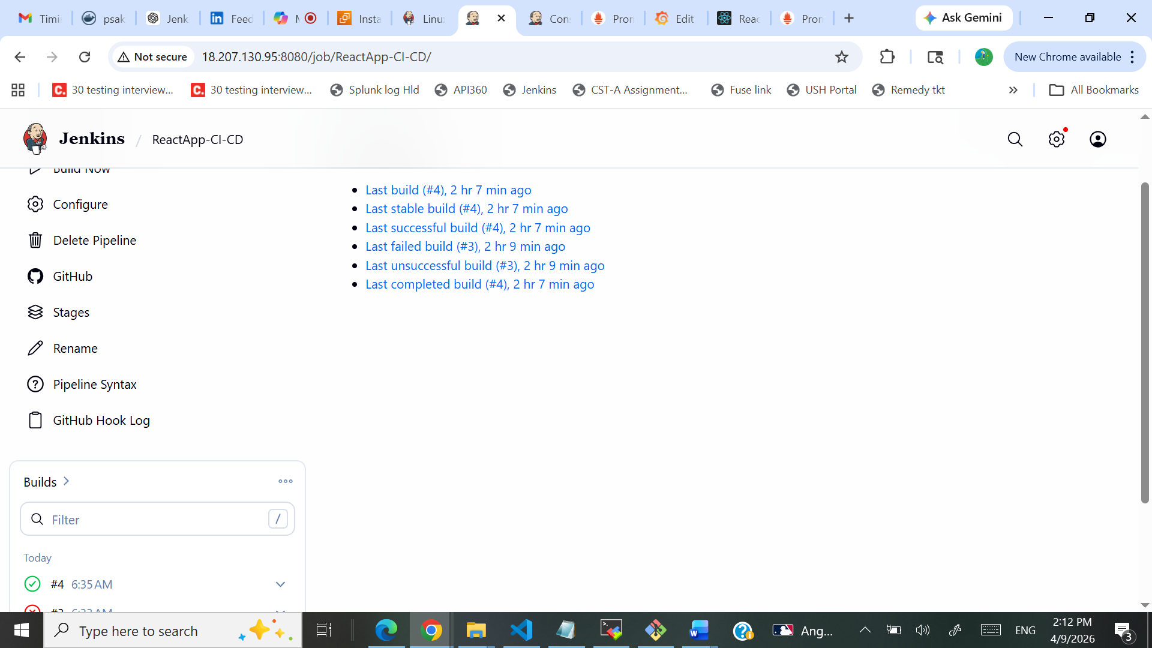

Console Output:
Started by user admin
[Pipeline] Start of Pipeline
[Pipeline] node
Running on Jenkins in /var/lib/jenkins/workspace/ReactApp-CI-CD
[Pipeline] {
[Pipeline] withEnv
[Pipeline] {
[Pipeline] stage
[Pipeline] { (Checkout)
[Pipeline] git
The recommended git tool is: NONE
No credentials specified
> git rev-parse --resolve-git-dir /var/lib/jenkins/workspace/ReactApp-CI-CD/.git # timeout=10
Fetching changes from the remote Git repository
> git config remote.origin.url https://github.com/psakthiece/Devops-build-Project.git # timeout=10
Fetching upstream changes from https://github.com/psakthiece/Devops-build-Project.git
> git --version # timeout=10
> git --version # 'git version 2.43.0'
> git fetch --tags --force --progress -- https://github.com/psakthiece/Devops-build-Project.git +refs/heads/*:refs/remotes/origin/* # timeout=10
> git rev-parse refs/remotes/origin/dev^{commit} # timeout=10
Checking out Revision 8c07b4750bce1254b86d23028d76692882b1e313 (refs/remotes/origin/dev)
> git config core.sparsecheckout # timeout=10
> git checkout -f 8c07b4750bce1254b86d23028d76692882b1e313 # timeout=10
> git branch -a -v --no-abbrev # timeout=10
> git branch -D dev # timeout=10
> git checkout -b dev 8c07b4750bce1254b86d23028d76692882b1e313 # timeout=10
Commit message: "Update Jenkinsfile"
> git rev-list --no-walk 8c07b4750bce1254b86d23028d76692882b1e313 # timeout=10
[Pipeline] }
[Pipeline] // stage
[Pipeline] stage
[Pipeline] { (Build Docker Image)
[Pipeline] sh
+ chmod +x build.sh
[Pipeline] sh
+ ./build.sh
Building Docker image...
DEPRECATED: The legacy builder is deprecated and will be removed in a future release.
Install the buildx component to build images with BuildKit:
https://docs.docker.com/go/buildx/

Sending build context to Docker daemon 7.156MB

Step 1/5 : FROM nginx:alpine
---> 645eda1c2477
Step 2/5 : RUN rm -rf /usr/share/nginx/html/*
---> Using cache
---> 0eef04bac0dc
Step 3/5 : COPY build/ /usr/share/nginx/html/
---> Using cache
---> d38b9027b317
Step 4/5 : EXPOSE 80
---> Using cache
---> 482a289d789d
Step 5/5 : CMD ["nginx", "-g", "daemon off;"]
---> Using cache
---> 3ccf3c0d07c3
Successfully built 3ccf3c0d07c3
Successfully tagged myapp:latest
Build completed!
[Pipeline] }
[Pipeline] // stage
[Pipeline] stage
[Pipeline] { (Push to Docker Hub)
[Pipeline] script
[Pipeline] {
[Pipeline] withCredentials
Masking supported pattern matches of $DOCKER_PASS
[Pipeline] {
[Pipeline] sh
Warning: A secret was passed to "sh" using Groovy String interpolation, which is insecure.
Affected argument(s) used the following variable(s): [DOCKER_PASS]
See https://jenkins.io/redirect/groovy-string-interpolation for details.
+ echo ****
+ docker login -u psakthiece --password-stdin
Login Succeeded
[Pipeline] sh
+ docker tag myapp:latest psakthiece/dev:latest
[Pipeline] sh
+ docker push psakthiece/dev:latest
The push refers to repository [docker.io/psakthiece/dev]
dbee391abeb0: Layer already exists
589002ba0eae: Layer already exists
ff9f59a6a62e: Layer already exists
a71873b303e8: Layer already exists
34dfdd2ef1f9: Layer already exists
1165b869c51a: Layer already exists
f03becc8ac15: Layer already exists
15e759724ff6: Layer already exists
c8a2fa3a88d2: Layer already exists
a3909080fa60: Layer already exists
latest: digest: sha256:3ccf3c0d07c3251e9d92efb0809b823e8ed6c2ff36576b05d0dd44804b0e64ae size: 2478
[Pipeline] }
[Pipeline] // withCredentials
[Pipeline] }
[Pipeline] // script
[Pipeline] }
[Pipeline] // stage
[Pipeline] stage
[Pipeline] { (Deploy to EC2)
[Pipeline] sshagent
[ssh-agent] Using credentials ec2-ssh-key
$ ssh-agent
SSH_AUTH_SOCK=/tmp/ssh-LUtTzy32rEzH/agent.45750
SSH_AGENT_PID=45753
Running ssh-add (command line suppressed)
Identity added: /var/lib/jenkins/workspace/ReactApp-CI-CD@tmp/private_key_2405737816887181494.key (/var/lib/jenkins/workspace/ReactApp-CI-CD@tmp/private_key_2405737816887181494.key)
[ssh-agent] Started.
[Pipeline] {
[Pipeline] sh
+ scp -o StrictHostKeyChecking=no deploy.sh docker-compose.yml ubuntu@18.207.130.95:/home/ubuntu/
Warning: Permanently added '18.207.130.95' (ED25519) to the list of known hosts.
+ ssh -o StrictHostKeyChecking=no ubuntu@18.207.130.95 chmod +x ~/deploy.sh && ~/deploy.sh
Deploying application...
time="2026-04-09T06:35:05Z" level=warning msg="/home/ubuntu/docker-compose.yml: the attribute `version` is obsolete, it will be ignored, please remove it to avoid potential confusion"
Network ubuntu_default Creating
Network ubuntu_default Created
Container myapp_container Creating
Container myapp_container Created
Container myapp_container Starting
Container myapp_container Started
Application deployed!
[Pipeline] }
$ ssh-agent -k
unset SSH_AUTH_SOCK;
unset SSH_AGENT_PID;
echo Agent pid 45753 killed;
[ssh-agent] Stopped.
[Pipeline] // sshagent
[Pipeline] }
[Pipeline] // stage
[Pipeline] stage
[Pipeline] { (Health Check)
[Pipeline] script
[Pipeline] {
[Pipeline] sh
+ curl -f http://18.207.130.95
% Total % Received % Xferd Average Speed Time Time Time Current
Dload Upload Total Spent Left Speed

0 0 0 0 0 0 0 0 --:--:-- --:--:-- --:--:-- 0
100 961 100 961 0 0 488k 0 --:--:-- --:--:-- --:--:-- 938k
<!doctype html><html lang="en"><head><meta charset="utf-8"/><link rel="icon" href="/favicon.ico"/><meta name="viewport" content="width=device-width,initial-scale=1"/><meta name="theme-color" content="#000000"/><meta name="description" content="Web site created using create-react-app"/><link rel="apple-touch-icon" href="/logo192.png"/><link rel="manifest" href="/manifest.json"/><link href="https://cdn.jsdelivr.net/npm/bootstrap@5.1.3/dist/css/bootstrap.min.css" rel="stylesheet" integrity="sha384-1BmE4kWBq78iYhFldvKuhfTAU6auU8tT94WrHftjDbrCEXSU1oBoqyl2QvZ6jIW3" crossorigin="anonymous"><link rel="stylesheet" href="https://cdn.jsdelivr.net/npm/bootstrap-icons@1.10.5/font/bootstrap-icons.css"><title>React App</title><script defer="defer" src="/static/js/main.f1c48542.js"></script><link href="/static/css/main.cf5c13c5.css" rel="stylesheet"></head><body><noscript>You need to enable JavaScript to run this app.</noscript><div id="root"></div></body></html>
[Pipeline] }
[Pipeline] // script
[Pipeline] }
[Pipeline] // stage
[Pipeline] stage
[Pipeline] { (Declarative: Post Actions)
[Pipeline] echo
Deployment successful!
[Pipeline] }
[Pipeline] // stage
[Pipeline] }
[Pipeline] // withEnv
[Pipeline] }
[Pipeline] // node
[Pipeline] End of Pipeline
Finished: SUCCESS
Deployed Application URL: http://18.207.130.95/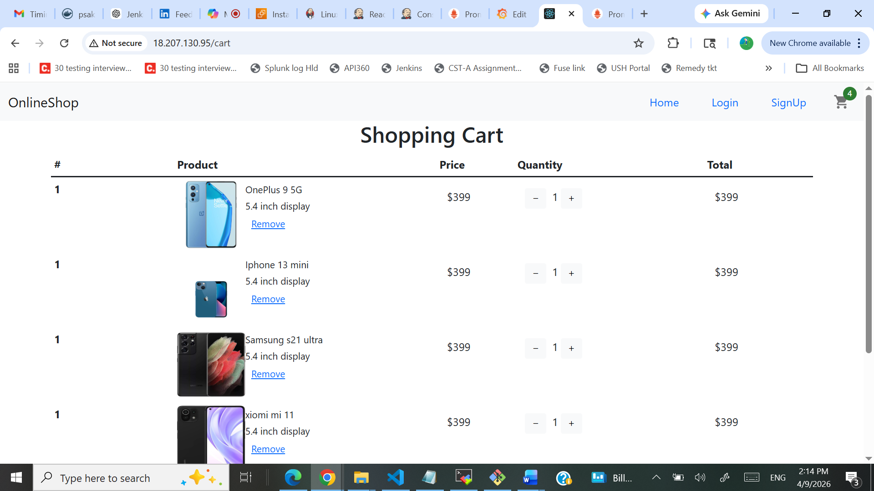

Monitoring:
- Prometheus installed in EC2 : http://18.207.130.95:9090/
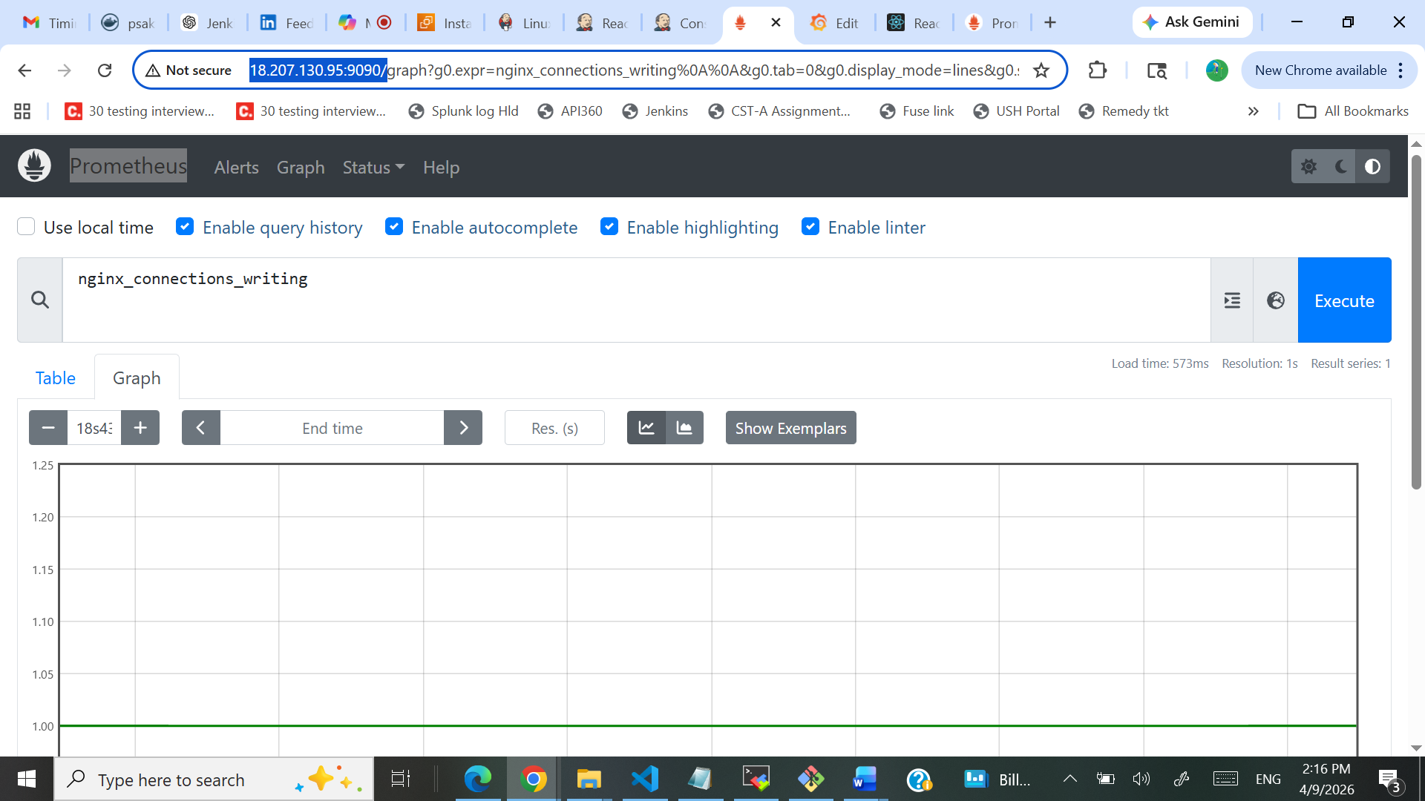
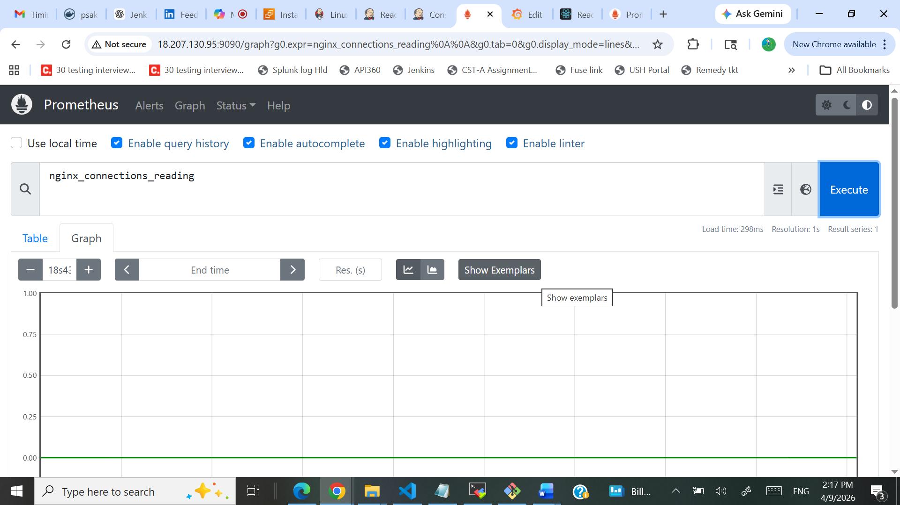
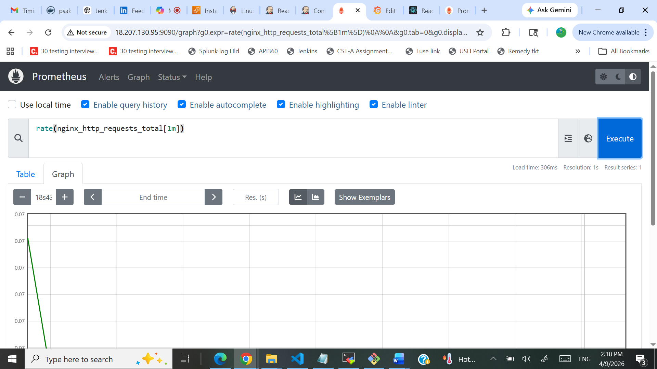
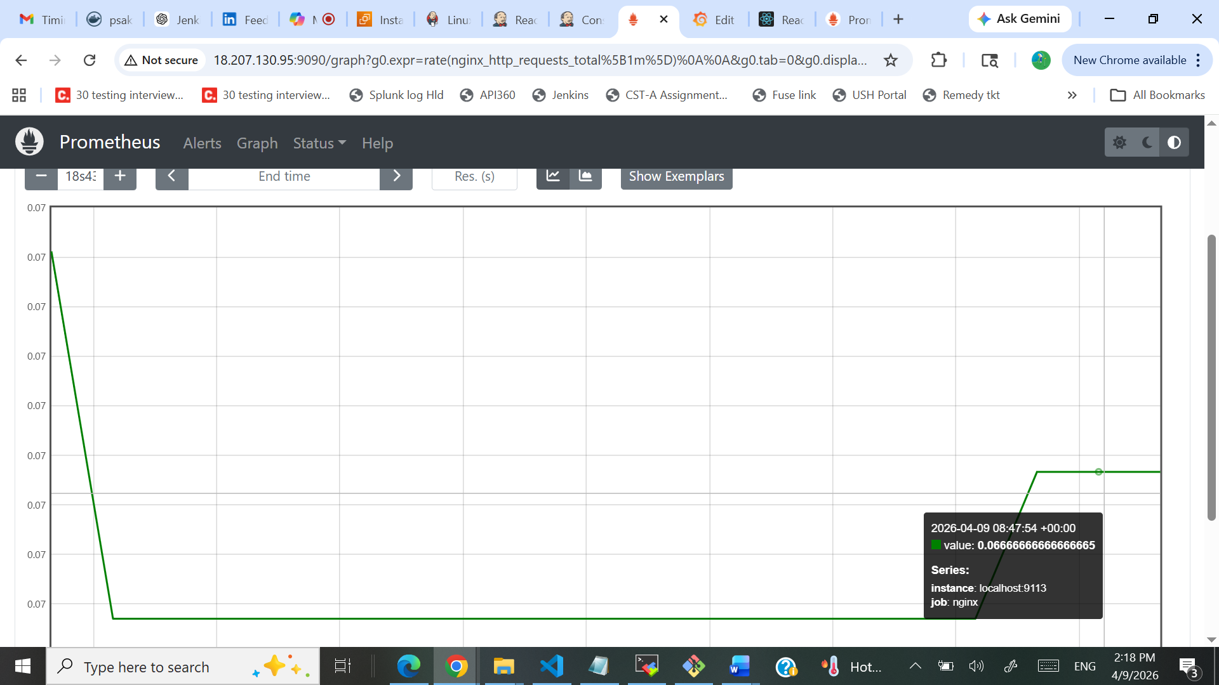
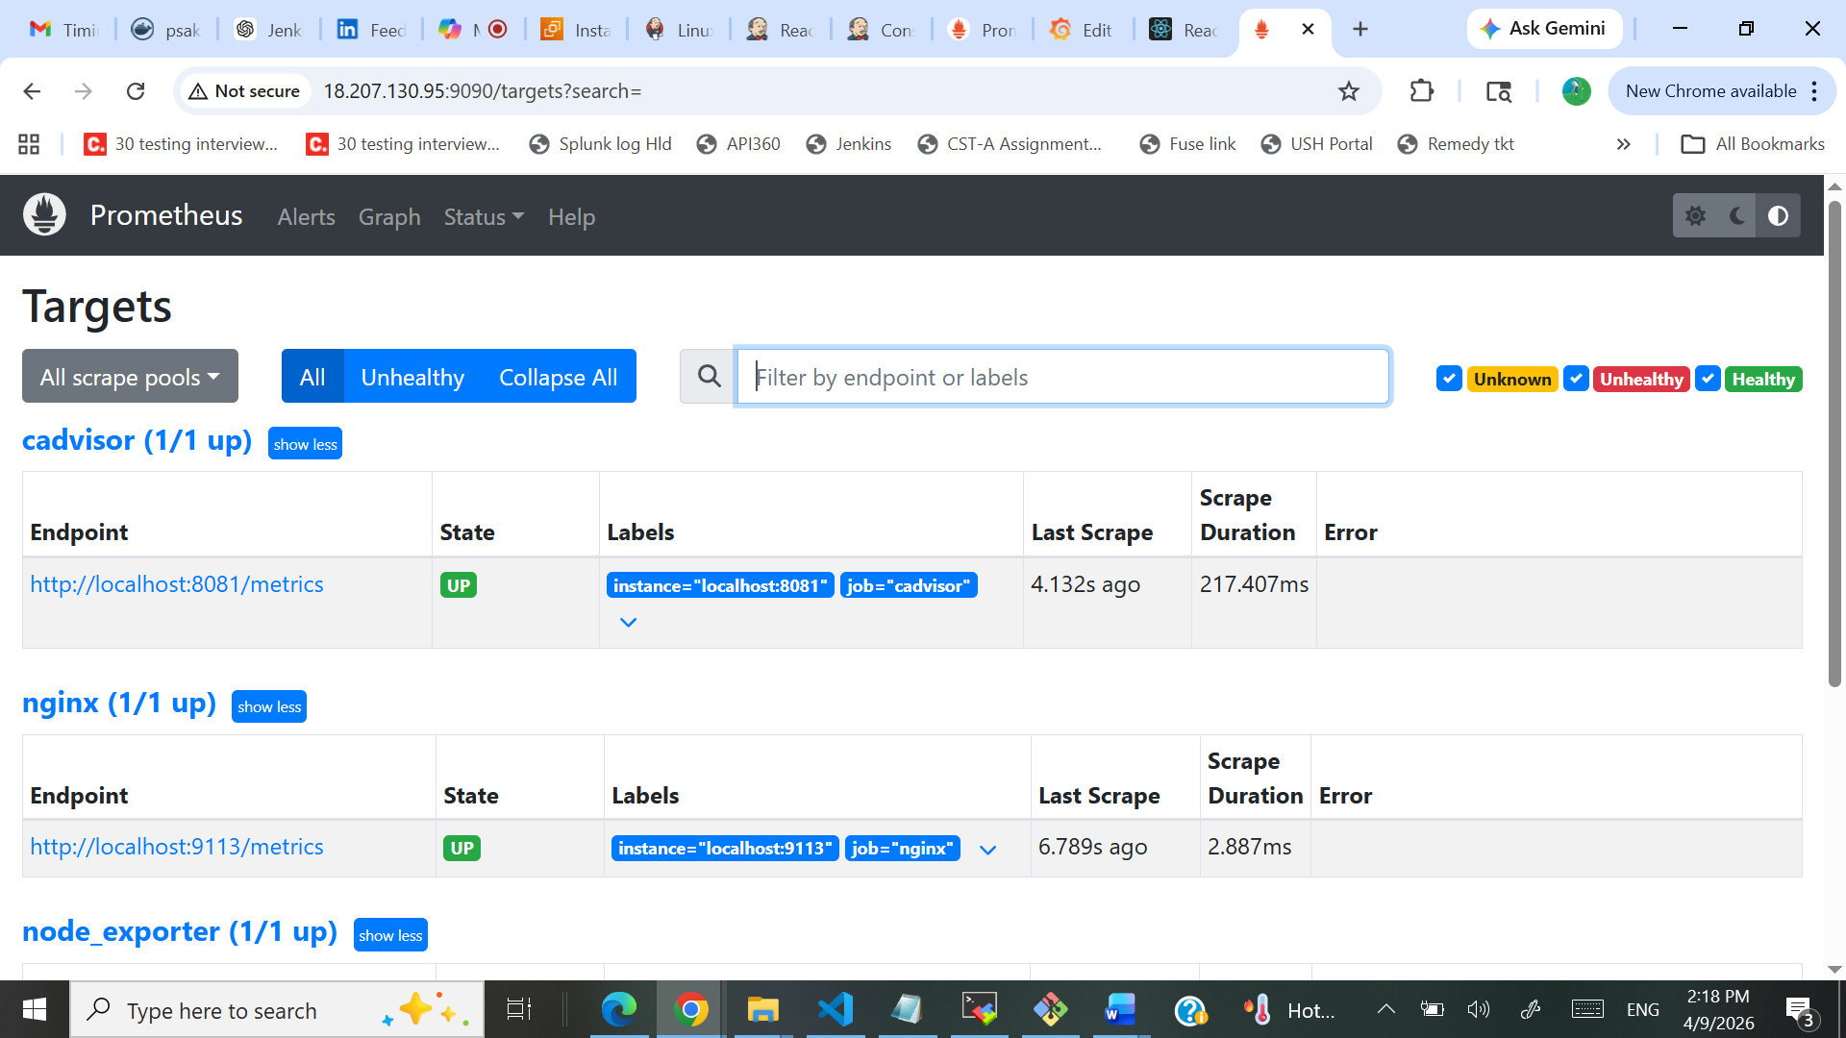
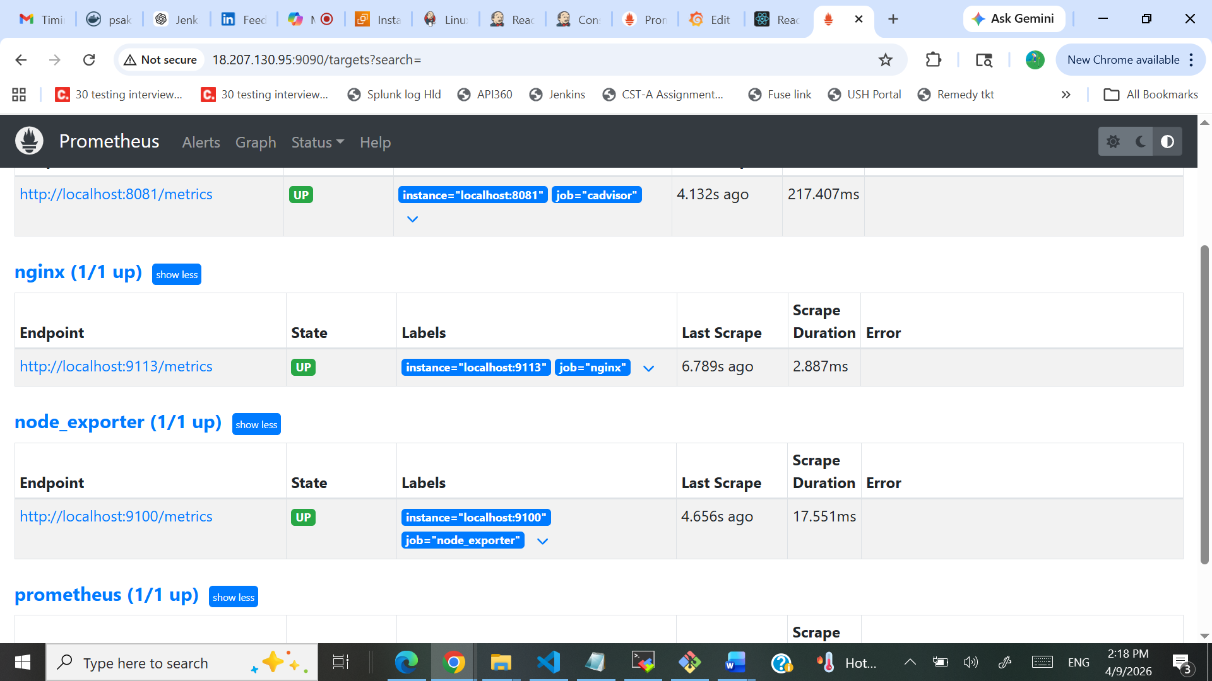
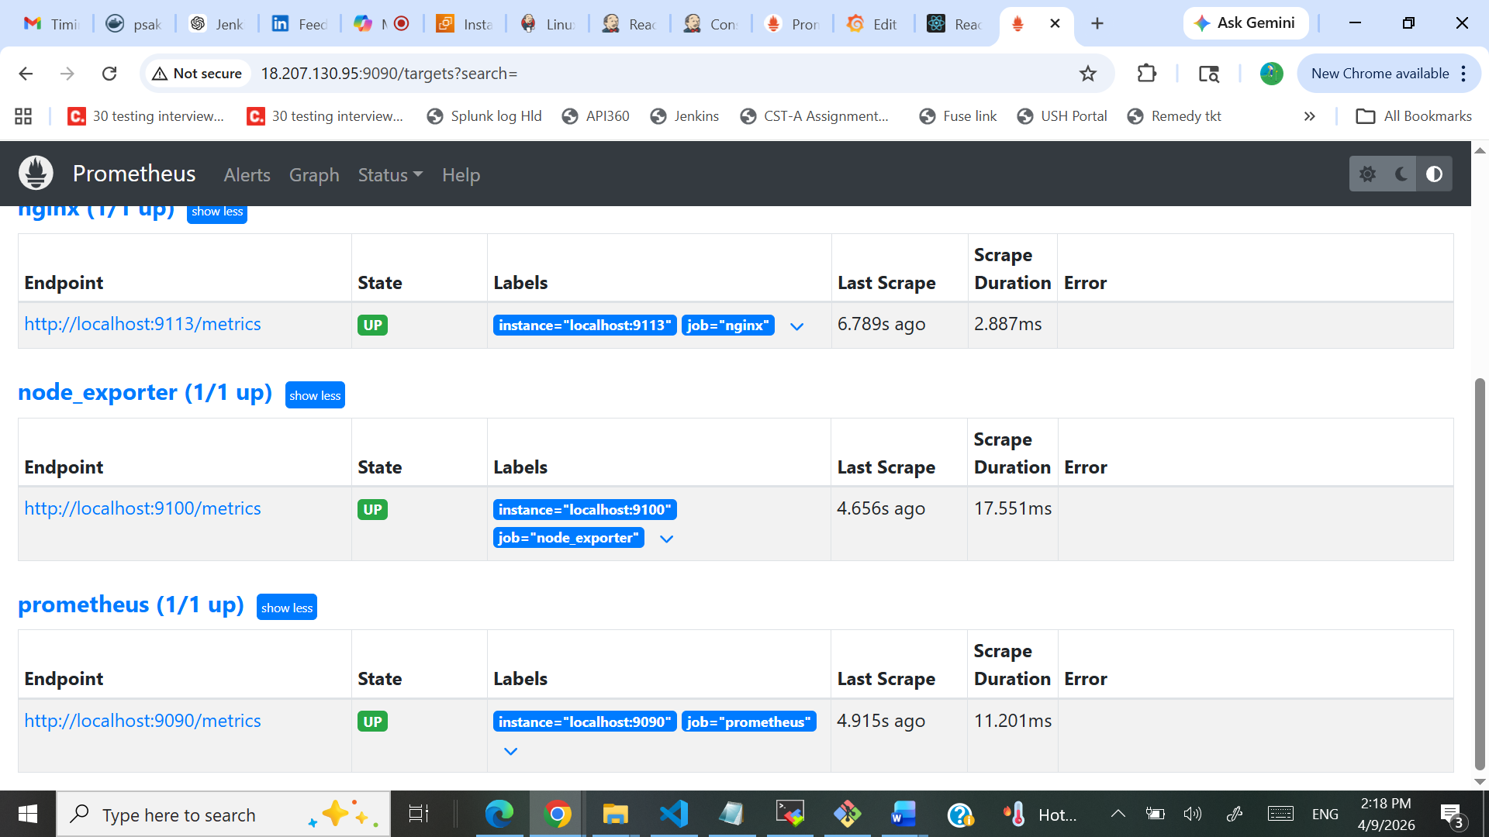
- Grafana installed in EC2 : http://18.207.130.95:3000/
